**JS Advanced Exam – 13 March 2022**

**Problem 1. Mails Delivery**

**Environment Specifics**

Please, be aware that every JS environment may **behave differently** when executing code. Certain things that work in the browser are not supported in **Node.js**, which is the environment used by **Judge**.

The following actions are **NOT** supported:

* **.forEach()** with **NodeList** (returned by **querySelector()** and **querySelectorAll()**)
* **.forEach()** with **HTMLCollection** (returned by **getElementsByClassName()** and **element.children**)
* Using the **spread-operator** (**...**) to convert a **NodeList** into an array
* **append()** in Judge (use only **appendChild()**)
* **replaceWith()** in Judge
* **replaceAll()** in Judge
* **closest()** in Judge
* **replaceChildren()**
* Always turn the collection into a **JS array** (forEach, forOf, etc.)

If you want to perform these operations, you may use **Array.from()** to first convert the collection into an array.

**Use the provided skeleton to solve this problem.**

**Note**: You **can't** and you have no permission to **change** directly the given HTML code (index.html file).

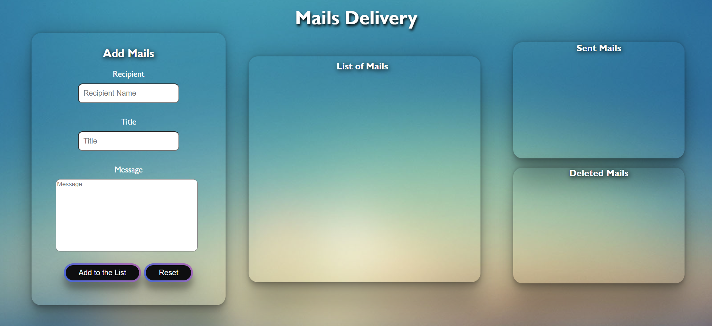

**Your Task**

**Write the missing JavaScript code** to make the **Mails Delivery** work as expected:

1. **Getting the information from the form**

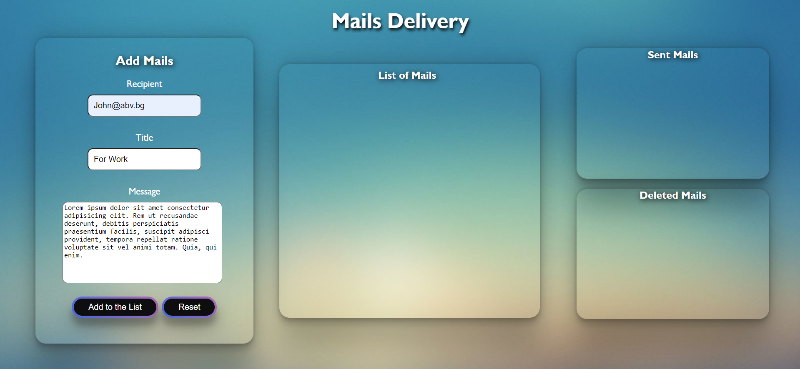

* **All fields** are **non**-**empty** **strings**. If any of them are empty, the program should not do anything.
* When you click the **["Add to the List"]** button, the information from the input fields must be added to the **ul** in **div** with **class ="list-mails",** and **inputs** must be cleared. The **structure** must be:

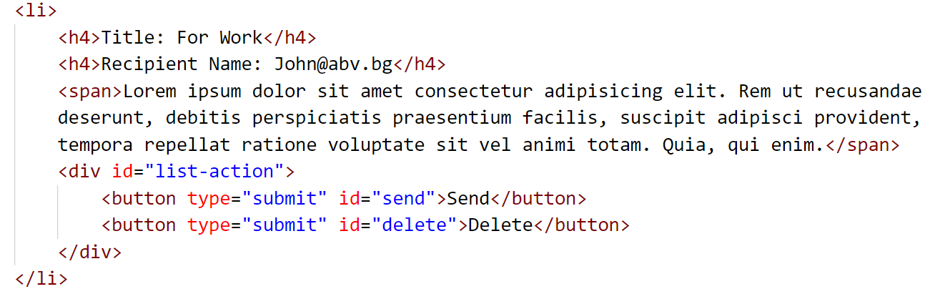

* The **Title** and **Recipient** **Name** must be saved in the **h4** tag and the message in the **span** tag.
* The Buttons - **Send** and **Delete** - are in **div** with **id="list-action".**

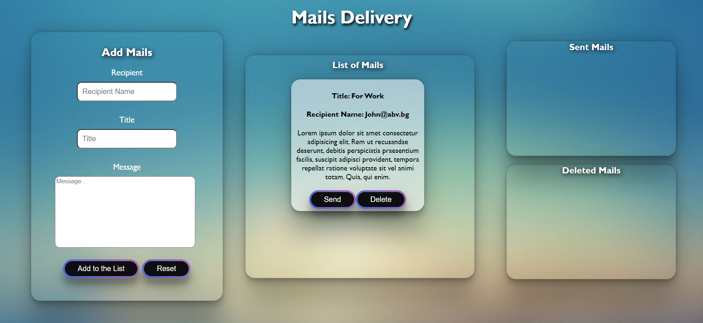

* When you click **["Reset"]**, the information from the inputs should be **cleared**, without any other changes.

1. **Send Mails**

* When the **["Send"]** button is clicked, the information must be sent to the **Sent Mails** and the **li** tag should be deleted from the **List of Mails**.

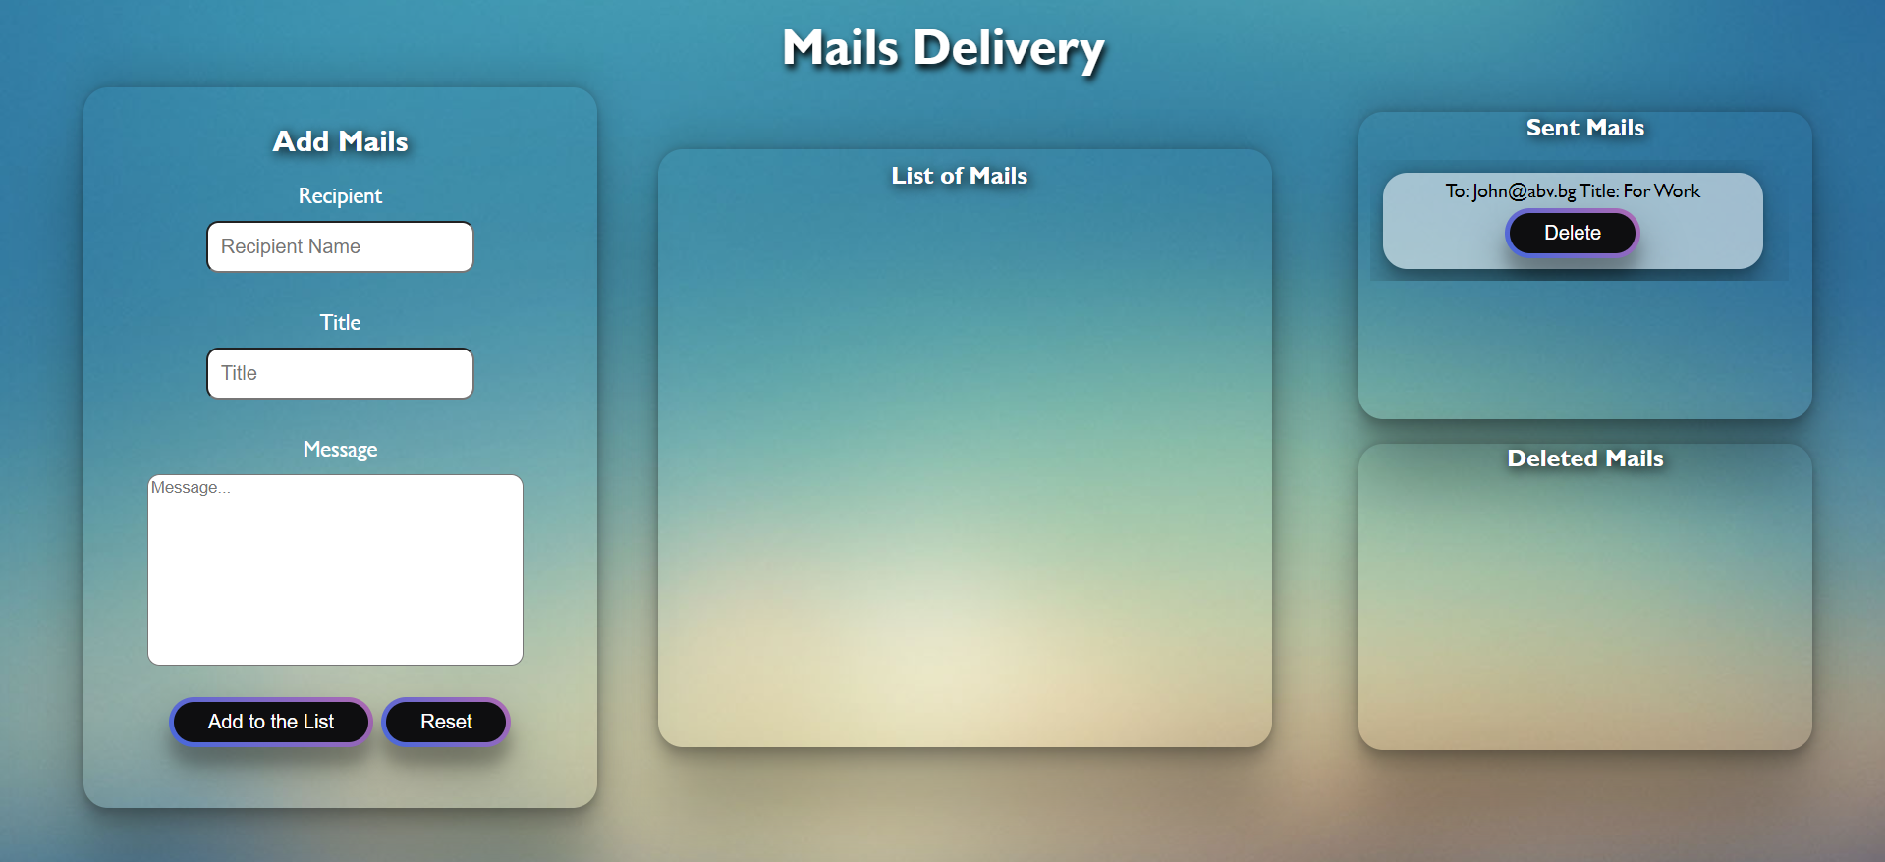

* The **structure** must be:

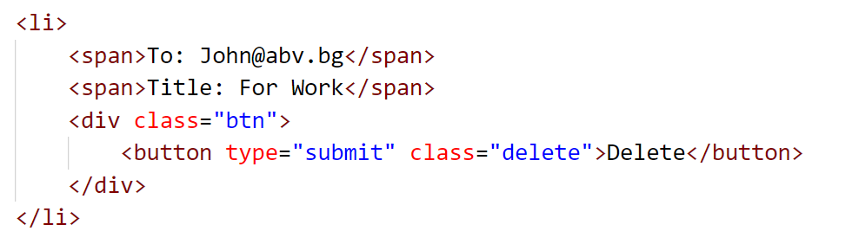

* The **Title** and **Recipient** **Name** must both be saved in the **span** tag.
* The **Button, Delete**, is in **div** with **class="btn".**

1. **Delete Mails**

* When you click the **["Delete"]** button, the information on either the **List of mails** or the **Sent mails** div, the information must be sent to the **Delete Mails** and the record should be deleted from the **List of Mails** or **Sent Mails**.

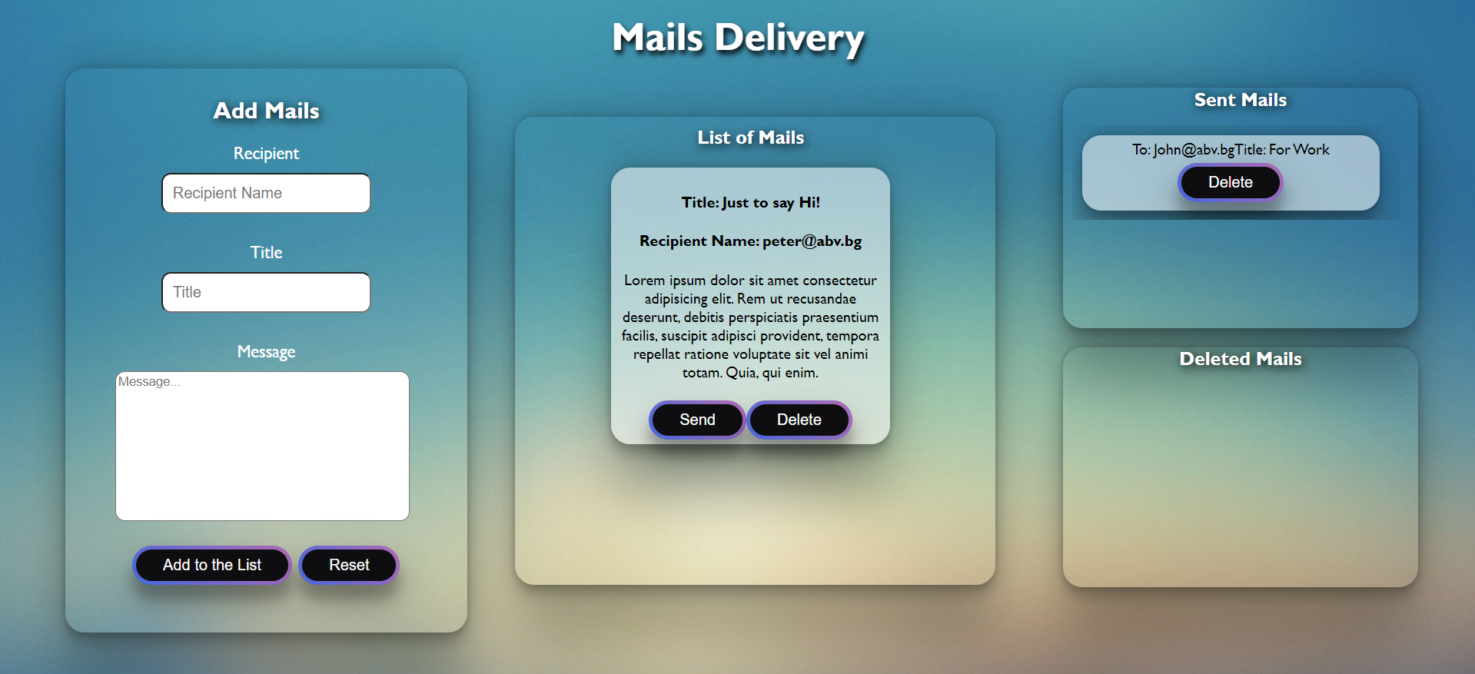

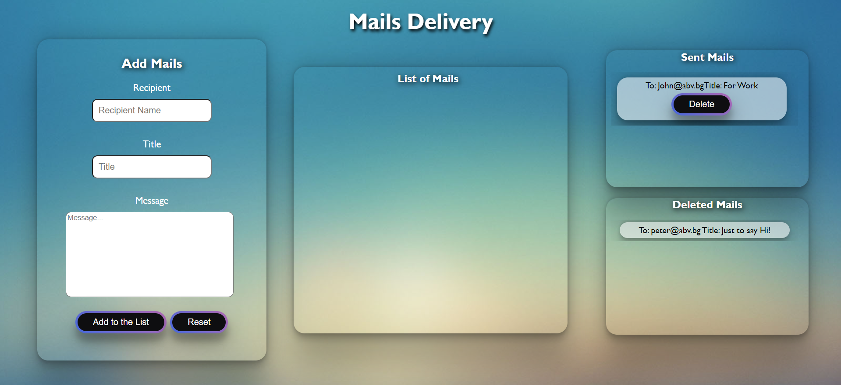

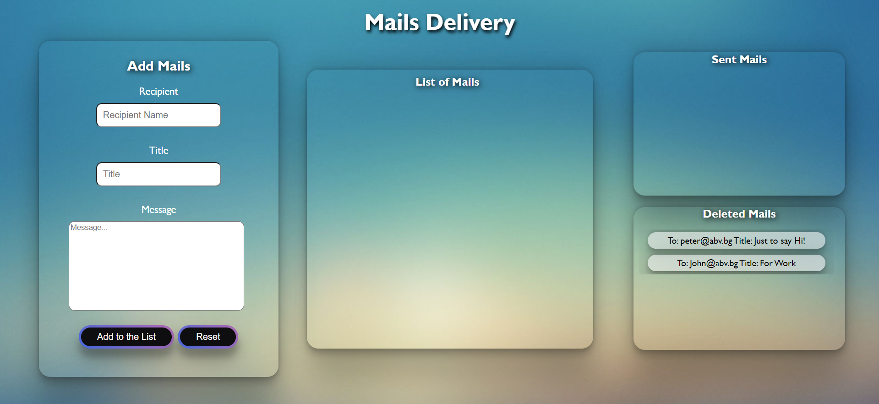

* The **structure** must be:

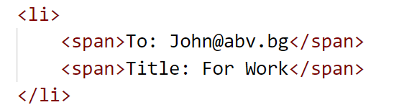

**Submission**

Submit only your **solve()** function.

*GOOD LUCK… ☺*